**Chapter 1**

**INTRODUCTION**

* 1. **AIM :**

Ferdinand Water Transport is website, which provides facility to book

and board the ship to small distance water surrounded lands. Some people who prefer the water voyages they can get to know about the information about the ships which check out from several coastal regional harbors to islands and cities.

* 1. **OBJECTIVE:**

There are so many ways of Transportation, such as Road Transportation, Air Transportation and Water Transportation. In these means of transportation, this project is all about Water Transportation System. Some people prefers to go by water for some places just of enjoyment, some for refreshment, by leaving traditional road and air transportation, and also in some places there is a typical situation of reaching destination through water means. Also some people prefer to go by water voyage to enjoy the sailing, living and travelling through waters (seas, oceans).

Our website will help those customers to book the seats in our company passenger ships to go voyage. Customer can register and book the trip in our company to visit various places in their own choose ships at their comfortable budget and schedule of voyage.

* 1. **MODULES:**

1. Index Page: This is the default and main page of the website.
2. Trip Page: This page specifies the trips available and it’s specifications.
3. Trip Booking Page: This page is like a application form for the registration of the customer to their desired trip.
4. Contact Page: This page contains space for submitting the feedback or query related to website and it’s services,
5. Customer Dashboard: This page contains the customer operations on the data of their trip like viewing the submission, editing/modifying the submission and deletes the submission/ cancel the trip.
6. Blog page: This page contains the uploaded blogs regarding water transportation and many social, economic and political aspects related blogs or writings.
7. Shop page: This page redirects the user to the many online shopping portals with offering exciting offers on related products and many coupons for discounts. This page mainly focuses on user engagement.
8. Entertainment Page: This page is embedded with many entertainment and education videos related to ships and water transport. This page mainly focuses on user engagement.

**Chapter 2**

**LITERATURE SURVEY**

**2.1 INTRODUCTION TO PHP**

Hypertext Preprocessor or simply PHP is a [general-purpose programming language](https://en.wikipedia.org/wiki/General-purpose_programming_language) originally designed for [web development](https://en.wikipedia.org/wiki/Web_development). It was originally created by [Rasmus Lerdorf](https://en.wikipedia.org/wiki/Rasmus_Lerdorf) in 1994, the PHP [reference implementation](https://en.wikipedia.org/wiki/Reference_implementation) is now produced by The PHP Group. PHP originally stood for Personal Home Page, but it now stands for the [recursive initialism](https://en.wikipedia.org/wiki/Recursive_initialism) *PHP:* Hypertext Preprocessor.

PHP code may be executed with a [command line interface](https://en.wikipedia.org/wiki/Command-line_interface) (CLI), embedded into [HTML](https://en.wikipedia.org/wiki/HTML) code, or used in combination with various [web template systems](https://en.wikipedia.org/wiki/Web_template_system), web [content management systems](https://en.wikipedia.org/wiki/Content_management_system), and [web frameworks](https://en.wikipedia.org/wiki/Web_framework). PHP code is usually processed by a PHP [interpreter](https://en.wikipedia.org/wiki/Interpreter_(computing)) implemented as a [module](https://en.wikipedia.org/wiki/Plugin_(computing)) in a web server or as a [Common Gateway Interface](https://en.wikipedia.org/wiki/Common_Gateway_Interface) (CGI) executable. The web server outputs the results of the interpreted and executed PHP code, which may be any type of data, such as generated HTML code or binary image data. PHP can be used for many programming tasks outside of the web context, such as [standalone](https://en.wikipedia.org/wiki/Computer_software) [graphical applications](https://en.wikipedia.org/wiki/Graphical_user_interface) and robotic [drone](https://en.wikipedia.org/wiki/Unmanned_aerial_vehicle) control.

The standard PHP interpreter, powered by the [Zend Engine](https://en.wikipedia.org/wiki/Zend_Engine), is [free software](https://en.wikipedia.org/wiki/Free_software) released under the [PHP License](https://en.wikipedia.org/wiki/PHP_License). PHP has been widely ported and can be deployed on most web servers on almost every [operating system](https://en.wikipedia.org/wiki/Operating_system) and [platform](https://en.wikipedia.org/wiki/Computing_platform), free of charge.

The fact that PHP was not originally designed, but instead was developed organically has led to inconsistent naming of functions and inconsistent ordering of their parameters. In some cases, the function names were chosen to match the lower-level libraries which PHP was "wrapping", while in some very early versions of PHP the length of the function names was used internally as a [hash function](https://en.wikipedia.org/wiki/Hash_function), so names were chosen to improve the distribution of hash values.

### PHP 3 and 4

[Zeev Suraski](https://en.wikipedia.org/wiki/Zeev_Suraski) and [Andi Gutmans](https://en.wikipedia.org/wiki/Andi_Gutmans) rewrote the [parser](https://en.wikipedia.org/wiki/Parser) in 1997 and formed the base of PHP 3, changing the language's name to the [recursive acronym](https://en.wikipedia.org/wiki/Recursive_acronym) *PHP:Hypertext Preprocessor.*Afterwards, public testing of PHP 3 began, and the official launch came in June 1998. Suraski and Gutmans then started a new [rewrite](https://en.wikipedia.org/wiki/Rewrite_(programming)) of PHP's core, producing the [Zend Engine](https://en.wikipedia.org/wiki/Zend_Engine) in 1999.They also founded [Zend Technologies](https://en.wikipedia.org/wiki/Zend_Technologies) in [Ramat Gan](https://en.wikipedia.org/wiki/Ramat_Gan), Israel.

On May 22, 2000, PHP 4, powered by the Zend Engine 1.0, was released.As of August 2008 this branch reached version 4.4.9. PHP 4 is no longer under development nor will any security updates be released.

### PHP 5

On July 14, 2004, PHP 5 was released, powered by the new Zend Engine II.PHP 5 included new features such as improved support for [object-oriented programming](https://en.wikipedia.org/wiki/Object-oriented_programming), the PHP Data Objects (PDO) extension (which defines a lightweight and consistent interface for accessing databases), and numerous performance enhancements.In 2008, PHP 5 became the only stable version under development. [Late static binding](https://en.wikipedia.org/wiki/Late_static_binding) had been missing from PHP and was added in version 5.3.

Many high-profile open-source projects ceased to support PHP 4 in new code as of February 5, 2008, because of the GoPHP5 initiative, provided by a consortium of PHP developers promoting the transition from PHP 4 to PHP 5.

Over time, PHP interpreters became available on most existing [32-bit](https://en.wikipedia.org/wiki/32-bit) and [64-bit](https://en.wikipedia.org/wiki/64-bit) operating systems, either by building them from the PHP source code, or by using pre-built binaries. For PHP versions 5.3 and 5.4, the only available [Microsoft Windows](https://en.wikipedia.org/wiki/Microsoft_Windows) binary distributions were 32-bit [IA-32](https://en.wikipedia.org/wiki/IA-32) builds, requiring Windows 32-bit compatibility mode while using [Internet Information Services](https://en.wikipedia.org/wiki/Internet_Information_Services) (IIS) on a 64-bit Windows platform. PHP version 5.5 made the 64-bit [x86-64](https://en.wikipedia.org/wiki/X86-64) builds available for Microsoft Window.

### PHP 6 and Unicode

PHP received mixed reviews due to lacking native [Unicode](https://en.wikipedia.org/wiki/Unicode) support at the core language level. In 2005, a project headed by Andrei Zmievski was initiated to bring native Unicode support throughout PHP, by embedding the [International Components for Unicode](https://en.wikipedia.org/wiki/International_Components_for_Unicode) (ICU) library, and representing text strings as [UTF-16](https://en.wikipedia.org/wiki/UTF-16) internally.Since this would cause major changes both to the internals of the language and to user code, it was planned to release this as version 6.0 of the language, along with other major features then in development.

However, a shortage of developers who understood the necessary changes, and performance problems arising from conversion to and from UTF-16, which is rarely used in a web context, led to delays in the project. As a result, a PHP 5.3 release was created in 2009, with many non-Unicode features back-ported from PHP 6, notably namespaces. In March 2010, the project in its current form was officially abandoned, and a PHP 5.4 release was prepared containing most remaining non-Unicode features from PHP 6, such as traits and closure re-binding. Initial hopes were that a new plan would be formed for Unicode integration, but as of 2014 none had been adopted.

### PHP 7

During 2014 and 2015, a new major PHP version was developed, which was numbered PHP 7. The numbering of this version involved some debate. While the PHP 6 Unicode experiment had never been released, several articles and book titles referenced the PHP 6 name, which might have caused confusion if a new release were to reuse the name. After a vote, the name PHP 7 was chosen.

The foundation of PHP 7 is a PHP [branch](https://en.wikipedia.org/wiki/Branching_(version_control)) that was originally dubbed *PHP next generation* (*phpng*). It was authored by Dmitry Stogov, Xinchen Hui and Nikita Popov, and aimed to optimize PHP performance by refactoring the Zend Engine while retaining near-complete language compatibility. As of 14 July 2014, [WordPress](https://en.wikipedia.org/wiki/WordPress)-based benchmarks, which served as the main benchmark suite for the phpng project, showed an almost 100% increase in performance. Changes from phpng are also expected to make it easier to improve performance in the future, as more compact data structures and other changes are seen as better suited for a successful migration to a [just-in-time](https://en.wikipedia.org/wiki/Just-in-time_compilation) (JIT) compiler. Because of the significant changes, the reworked Zend Engine is called *Zend Engine 3*, succeeding Zend Engine 2 used in PHP 5.

**2.2 APACHE**

The **Apache HTTP Server**, colloquially called **Apache**, is [free and open-source](https://en.wikipedia.org/wiki/Free_and_open-source) [cross-platform](https://en.wikipedia.org/wiki/Cross-platform) [web server](https://en.wikipedia.org/wiki/Web_server) software, released under the terms of [Apache License](https://en.wikipedia.org/wiki/Apache_License) 2.0. Apache is developed and maintained by an open community of developers under the auspices of the [Apache Software Foundation](https://en.wikipedia.org/wiki/Apache_Software_Foundation).

The vast majority of Apache HTTP Server instances run on a [Linux distribution](https://en.wikipedia.org/wiki/Linux_distribution), but current versions also run on [Microsoft Windows](https://en.wikipedia.org/wiki/Microsoft_Windows) and a wide variety of [Unix-like](https://en.wikipedia.org/wiki/Unix-like) systems. Past versions also ran on [OpenVMS](https://en.wikipedia.org/wiki/OpenVMS), [NetWare](https://en.wikipedia.org/wiki/NetWare), [OS/2](https://en.wikipedia.org/wiki/OS/2) and other operating systems, including ports to mainframes.

Originally based on the NCSA HTTPd server, development of Apache began in early 1995 after work on the NCSA code stalled. Apache played a key role in the initial growth of the [World Wide Web](https://en.wikipedia.org/wiki/World_Wide_Web), quickly overtaking NCSA HTTPd as the dominant [HTTP](https://en.wikipedia.org/wiki/HTTP) server, and has remained most popular since April 1996. In 2009, it became the first web server software to serve more than 100 million [websites](https://en.wikipedia.org/wiki/Website). As of August 2019, it was estimated to serve 29% of all active websites, ranked 2nd after [nginx](https://en.wikipedia.org/wiki/Nginx) at 32%, and 32% of the top million websites, ranked 2nd after "Other" with 33%.

Instead of implementing a single architecture, Apache provides a variety of MultiProcessing Modules (MPMs), which allow it to run in either a [process](https://en.wikipedia.org/wiki/Process_(computing))-based mode, a hybrid (process and [thread](https://en.wikipedia.org/wiki/Thread_(computing))) mode, or an event-hybrid mode, in order to better match the demands of each particular infrastructure. Choice of MPM and configuration is therefore important. Where compromises in performance must be made, Apache is designed to reduce [latency](https://en.wikipedia.org/wiki/Latency_(engineering)#Computer_hardware_and_operating_system_latency) and increase [throughput](https://en.wikipedia.org/wiki/Throughput) relative to simply handling more requests, thus ensuring consistent and reliable processing of requests within reasonable time-frames.

The Apache HTTP Server [codebase](https://en.wikipedia.org/wiki/Codebase) was [relicensed](https://en.wikipedia.org/wiki/Software_relicensing) to the [Apache 2.0 License](https://en.wikipedia.org/wiki/Apache_License) (from the previous 1.1 license) in January 2004, and Apache HTTP Server 1.3.31 and 2.0.49 were the first [releases](https://en.wikipedia.org/wiki/Software_release_life_cycle) using the new license.

**Version 1.1:** The Apache License 1.1 was approved by the ASF in 2000: The primary change from the 1.0 license is in the 'advertising clause' (section 3 of the 1.0 license); derived products are no longer required to include attribution in their advertising materials, only in their documentation.

**Version 2.0:** The ASF adopted the Apache License 2.0 in January 2004. The stated goals of the license included making the license easier for non-ASF projects to use, improving compatibility with GPL-based software, allowing the license to be included by reference instead of listed in every file, clarifying the license on contributions, and requiring a patent license on contributions that necessarily infringe a contributor's own patents.

**2.3 MySQL**

**MySQL** is an [open-source](https://en.wikipedia.org/wiki/Open-source_software) [relational database management system](https://en.wikipedia.org/wiki/Relational_database_management_system) (RDBMS).Its name is a combination of "My", the name of co-founder [Michael Widenius](https://en.wikipedia.org/wiki/Michael_Widenius)'s daughter, and "[SQL](https://en.wikipedia.org/wiki/SQL)", the abbreviation for [Structured Query Language](https://en.wikipedia.org/wiki/Structured_Query_Language).

MySQL is [free and open-source software](https://en.wikipedia.org/wiki/Free_and_open-source_software) under the terms of the [GNU General Public License](https://en.wikipedia.org/wiki/GNU_General_Public_License), and is also available under a variety of [proprietary](https://en.wikipedia.org/wiki/Proprietary_software) licenses. MySQL was owned and sponsored by the [Swedish](https://en.wikipedia.org/wiki/Sweden) company [MySQL AB](https://en.wikipedia.org/wiki/MySQL_AB), which was bought by [Sun Microsystems](https://en.wikipedia.org/wiki/Sun_Microsystems) (now [Oracle Corporation](https://en.wikipedia.org/wiki/Oracle_Corporation)). In 2010, when Oracle acquired Sun, Widenius [forked](https://en.wikipedia.org/wiki/Fork_(software_development)) the [open-source](https://en.wikipedia.org/wiki/Open-source) MySQL project to create [MariaDB](https://en.wikipedia.org/wiki/MariaDB).

MySQL is a component of the [LAMP](https://en.wikipedia.org/wiki/LAMP_(software_bundle)) [web application](https://en.wikipedia.org/wiki/Web_application) [software stack](https://en.wikipedia.org/wiki/Software_stack) (and [others](https://en.wikipedia.org/wiki/List_of_AMP_packages)), which is an acronym for [*Linux*](https://en.wikipedia.org/wiki/Linux)*,*[*Apache*](https://en.wikipedia.org/wiki/Apache_HTTP_Server)*, MySQL,*[*Perl*](https://en.wikipedia.org/wiki/Perl)*/*[*PHP*](https://en.wikipedia.org/wiki/PHP)*/*[*Python*](https://en.wikipedia.org/wiki/Python_(programming_language)). MySQL is used by many database-driven web applications, including [Drupal](https://en.wikipedia.org/wiki/Drupal), [Joomla](https://en.wikipedia.org/wiki/Joomla), [phpBB](https://en.wikipedia.org/wiki/PhpBB) and, [WordPress](https://en.wikipedia.org/wiki/WordPress).

MySQL is written in [C](https://en.wikipedia.org/wiki/C_(programming_language)) and [C++](https://en.wikipedia.org/wiki/C++). Its SQL parser is written in [yacc](https://en.wikipedia.org/wiki/Yacc), but it uses a home-brewed [lexical analyzer](https://en.wikipedia.org/wiki/Lexical_analysis).MySQL works on many [system platforms](https://en.wikipedia.org/wiki/System_platform), including [AIX](https://en.wikipedia.org/wiki/AIX_operating_system), [BSDi](https://en.wikipedia.org/wiki/BSD/OS), [FreeBSD](https://en.wikipedia.org/wiki/FreeBSD), [HP-UX](https://en.wikipedia.org/wiki/HP-UX), [eComStation](https://en.wikipedia.org/wiki/EComStation), [i5/OS](https://en.wikipedia.org/wiki/IBM_i5/OS), [IRIX](https://en.wikipedia.org/wiki/IRIX), [Linux](https://en.wikipedia.org/wiki/Linux), [macOS](https://en.wikipedia.org/wiki/MacOS), [Microsoft Windows](https://en.wikipedia.org/wiki/Microsoft_Windows),[NetBSD](https://en.wikipedia.org/wiki/NetBSD), [Novell,NetWare](https://en.wikipedia.org/wiki/Novell_NetWare), [OpenBSD](https://en.wikipedia.org/wiki/OpenBSD), [OpenSolaris](https://en.wikipedia.org/wiki/OpenSolaris), [OS/2](https://en.wikipedia.org/wiki/OS/2) Warp, [QNX](https://en.wikipedia.org/wiki/QNX), [Oracle Solaris](https://en.wikipedia.org/wiki/Solaris_(operating_system)), [Symbian](https://en.wikipedia.org/wiki/Symbian), [SunOS](https://en.wikipedia.org/wiki/SunOS), [SCO OpenServer](https://en.wikipedia.org/wiki/SCO_OpenServer), SCO [UnixWare](https://en.wikipedia.org/wiki/UnixWare), Sanos and [Tru64](https://en.wikipedia.org/wiki/Tru64_UNIX). A port of MySQL to [OpenVMS](https://en.wikipedia.org/wiki/OpenVMS) also exists.

MySQL was created by a Swedish company, [MySQL AB](https://en.wikipedia.org/wiki/MySQL_AB), founded by [David Axmark](https://en.wikipedia.org/wiki/David_Axmark), Allan Larsson and [Michael "Monty" Widenius](https://en.wikipedia.org/wiki/Michael_(Monty)_Widenius). Original development of MySQL by Widenius and Axmark began in 1994. The first version of MySQL appeared on 23 May 1995. It was initially created for personal usage from [mSQL](https://en.wikipedia.org/wiki/MSQL) based on the low-level language [ISAM](https://en.wikipedia.org/wiki/ISAM), which the creators considered too slow and inflexible. They created a new [SQL](https://en.wikipedia.org/wiki/Structured_Query_Language) interface, while keeping the same [API](https://en.wikipedia.org/wiki/Application_programming_interface) as mSQL. By keeping the API consistent with the mSQL system, many developers were able to use MySQL instead of the (proprietarily licensed) mSQL antecedent.

MySQL is offered under two different editions: the [open source](https://en.wikipedia.org/wiki/Open-source_software) MySQL Community Server and the proprietary [Enterprise Server](https://en.wikipedia.org/wiki/MySQL_Enterprise). MySQL Enterprise Server is differentiated by a series of proprietary extensions which install as server plugins, but otherwise shares the version numbering system and is built from the same code base.

* 1. **INTRODUCTION TO HTML**

HTML(hypertext mark-up language) is used to create document on the world wide web. It is simply collection of certain keywords called “Tags” that are helpful in writing the document to be displayed using a browser on internet.

It is a platform independent language that can be used on any platform such as windows and so on. To display a document in webit is essential to mark-up the different elements(headings, paragraph, tables and so on) of the document with the html tags. To view a mark-up document, user has to open the document in a browser. A browser understands and interpret the html tags, identifies the structure of the document and makes a decision about presentation of the document.

HTML also provides tags to make the document look attractive using graphics , font size and colors. users can make a link to the other document or the different section of the same document by creating hypertext links also known as hyperlinks.

* + 1. **BASIC HTML TAGS**

<head> This tag defines the information about the document.

<body> This tag contains the content of the document.

<headings>This tag is used to create the headlines in document.

<img> This tag is used to insert the images in a document.

<anchor> This tag is used to link the web pages,

<font> This tag defines the font style, size and color of the text.

<hr> This tag is used to insert the horizontal line

<form> This forms are sections to document that contains control used to called inputs from the user

<frame> This tag divides a frames into rectangular area on the window.

<br> This tag is used to give the one line space

<table> This tag is a collection of information arranged in a rows and columns.

<ul> This tag is used to list the items where ordering is not specify.

<frameset>This tag is used to divide the rectangular areas each of which in a frames.

<title> This tag defines the title of the document.

<div> This tag is used to divide the sections or divisions in a HTML document.

<marquee>This tag is used to get a moving text/image on web page

* 1. **INTRODUCTION TO CSS**

Cascading style sheets, fondly referred to has CSS, is a simple design language intended to simplify the process making presentable.

CSS handles the look and feel part of a webpage. Using CSS, you can control the color of the text, the style of the fonts, the spacing between the paragraphs, how columns are sized and laid out, what background images are color are used , as well as a variety of other effects.

CSS is easy to learn and understand but it provide a powerful control over the presentation of an html document. Most commonly, CSS is combined with the mark-up languages html or XHTML

It is usually stored in separate. CSS style is which can be reused for all the web pages.

HTML + CSS = WEBPAGE

(Content) (Presentation)

We can write CSS once and then reuse same sheet in multiple HTML pages.

* 1. **INTRODUCTION TO BOOTSTRAP**

**Bootstrap** is a free and open-source CSS framework directed at responsive, mobile-first front-end web development. It contains CSS and (optionally) JavaScript based design templates for typography, forms, buttons, navigation, and other interface components.

Bootstrap is the fifth-most-starred project on GitHub, with more than 142,000 stars, behind freeCodeCamp (almost 312,000 stars) and marginally behind Veu.js framework. According to Alexa Rank, Bootstrap is in the top-2000 in the USA while vuejs.org is in the top-7000 in the USA.

**Chapter 3**

**SOFTWARE REQUIREMENTS SPECIFICATION**

* 1. **HARDWARE REQUIREMENTS**

Hard disk : 10 GB minimum

RAM : 4GB

Processor : Intel Core i3 7th Gen

* 1. **SOFTWARE REQUIREMENTS**

Operating System : Windows 10

Application Browser : Google chrome

Interface Languages : HTML, CSS, Bootstrap 4

Scripting Language : PHP

Query Language : MySQL

Database : phpMyAdmin

Server Deployment : Infinityfree.net

**Chapter 4**

**SYSTEM DESIGN**

**4.1 Input Design**

Input Design is the most important part of overall system design, which requires very carefully attention. Often the collection input data is the most expensive part of the system. Many errors occur during this phase of the design. So to make the system study, the inputs given by the user is strictly validated before making a manipulation with it thus, by validation it is possible to

* Provide an effective method of input.
* Achieve the highest possible level of accuracy.
* Ensure that input is acceptable and understood by the staff.

Input design is mainly concentrated on estimating what the inputs are and how they to be arranged on the input screen, how frequently the ideas are to be collected. Project Tracking System provides many user-friendly features that help the user to interact with the system easily.

The input screen is designed in such a manner that avoids confusion and guides the user in the correct track. Although study has been made on the type and how the input form is to be designed. Some inputs form the user may cause severe error and is strictly validated.

This PTS software provides a point and click to its users. The layout of the input screen is also taken into account. A very good luck and feel is provided through the organize arrangement of controls such as menus, tabs, and dialog boxes, buttons etc…

Input screen for PTS are very simple and user friendly users are allowed to access the software only after the authentication process. If irrelevant data is entered the validates will display the

Error-message.

**4.2 Output Design**

The output design generally refers to the results generated by the system. For many end users, output is the main reason for developing the system and the basis on which they evaluate the usefulness of the applications.

The objective of a system finds its shape in terms of input. The analysis of the objective of a system leads to the determination of outputs. The most common type of output is screen displays.

The output also varies in terms of their contents,frequency,timing and format. The users of output, its purpose and sequence of details to be printed are all considered. If the outputs are inadequate in any way the system itself is inadequate.

The basic requirement of output is it should be accurate, timely and appropriate. When designing output, the system analyst must accomplish things like determining what information to be present, whether to display or print the information, select output medium and to decide how to distribute the output to intended recipients.

The types of outputs are

* External Outputs
* Internal Outputs
* Interactive Outputs
* **External Outputs:** These are the types of outputs whose destination will be outside the organization and which requires special attention as they project the image of the organization.
* **Internal Outputs:** These are the types of outputs whose destination will be outside the organization. It is to be carefully designed as they are the user’s main interface with the system.
* **Interactive Outputs:** These are the types of outputs which the user uses in communicating directly with the system.

**4.3 DFD and ER-diagram**

4.3.1 DFD Level-0

Customer Management

Booking Management

Customer Problem Management

Generate Customer Report

4.3.2 DFD Level-1

Check Customer Details

Booking Management

Data Management

Data Management

**4.3.3 DFD Level-2**

Admin

Manage Trip Bookings

Manage Customer request

**4.3.4 ER Diagram**

Trip Booking

Has

1

Primary Details form

Trip Status Dashboard

Has

1

1

1

1

Manage

Modify/ Update

Delete/ Cancel

Display/ Show

**Chapter 5**

**CODING**

Index.html

<!doctype html>

<html lang="en">

<head>

<meta charset="utf-8">

<meta name="viewport" content="width=device-width, initial-scale=1, shrink-to-fit=no">

<link rel="stylesheet" href="https://maxcdn.bootstrapcdn.com/bootstrap/4.0.0/css/bootstrap.min.css" integrity="sha384-Gn5384xqQ1aoWXA+058RXPxPg6fy4IWvTNh0E263XmFcJlSAwiGgFAW/dAiS6JXm" crossorigin="anonymous">

<link rel="stylesheet" type="text/css" href="style.css">

<title>Ferdinand Water Transport</title>

<link rel="shortcut icon" type="image/jpg" href="images/favicon.png"/>

</head>

<body>

<div class="header">

<a href="index.php"><img src="images\logo_header.png" width="420" height="125"></a>

</div>

<nav class="navbar navbar-expand-lg navbar-light bg-light">

<a class="navbar-brand" href="index.php">Home</a>

<button class="navbar-toggler" type="button" data-toggle="collapse" data-target="#navbarSupportedContent" aria-controls="navbarSupportedContent" aria-expanded="false" aria-label="Toggle navigation">

<span class="navbar-toggler-icon"></span>

</button>

<div class="collapse navbar-collapse" id="navbarSupportedContent">

<ul class="navbar-nav mr-auto">

<li class="nav-item active">

<a class="nav-link" href="trip.php">Trips <span class="sr-only">(current)</span></a>

</li>

<li class="nav-item dropdown">

<a class="nav-link dropdown-toggle" href="#" id="navbarDropdown" role="button" data-toggle="dropdown" aria-haspopup="true" aria-expanded="false">

Status

</a>

<div class="dropdown-menu" aria-labelledby="navbarDropdown">

<a class="dropdown-item" href="mytrip.php">My Trips</a>

<a class="dropdown-item" href="mytrip.php">Update my Trip Details</a>

<div class="dropdown-divider"></div>

<a class="dropdown-item" href="contact.php">Talk to an Executive</a>

</div>

</li>

<li class="nav-item">

<a class="nav-link" href="blog.php">Blog</a>

</li>

<li class="nav-item">

<a class="nav-link" href="contact.php">Contact</a>

</li>

<li class="nav-item">

<a class="nav-link" href="shop.php">Shop</a>

</li>

<li class="nav-item">

<a class="nav-link" href="fwttv.php">Entertainment</a>

</li>

</ul>

<form class="form-inline my-2 my-lg-0">

<input class="form-control mr-sm-2" type="search" placeholder="Search" aria-label="Search">

<button class="btn btn-outline-success my-2 my-sm-0" type="submit">Search</button>

</form>

</div>

</nav>

<div id="carouselExampleIndicators" class="carousel slide" data-ride="carousel">

<ol class="carousel-indicators">

<li data-target="#carouselExampleIndicators" data-slide-to="0" class="active"></li>

<li data-target="#carouselExampleIndicators" data-slide-to="1"></li>

<li data-target="#carouselExampleIndicators" data-slide-to="2"></li>

</ol>

<div class="carousel-inner">

<div class="carousel-item active">

<img class="d-block w-100" src="images\Andaman-Nicobar.webp" alt="First slide">

</div>

<div class="carousel-item">

<img class="d-block w-100" src="images\mangalore.jpg" alt="Second slide">

</div>

<div class="carousel-item">

<img class="d-block w-100" src="images\portblair.jpg" alt="Third slide">

</div>

</div>

<a class="carousel-control-prev" href="#carouselExampleIndicators" role="button" data-slide="prev">

<span class="carousel-control-prev-icon" aria-hidden="true"></span>

<span class="sr-only">Previous</span>

</a>

<a class="carousel-control-next" href="#carouselExampleIndicators" role="button" data-slide="next">

<span class="carousel-control-next-icon" aria-hidden="true"></span>

<span class="sr-only">Next</span>

</a>

</div>

<div class="col-md">

The Ferdinand Water Transport is a water transport system

made specially for the people who loves the water ways and

voyages. The ships from various harbours of the Indian

coastal regions lead to place a voyage to islands or near

by neighbouring countries, like Sri Lanka, Andaman and

Nicober, Lakshadweep, and some other Islands or penesular

countries.

Our Ports are located in Mangalore, Vishakapatanam and Kochi.

Still company is planning to start the ports in Mahabalipuram,

Mumbai, Goa and Karvar.

The Customers will be exiciting offers on the every booking

and as they become old Customer to the company.

Starting package of shipping is INR 2,400[Mangalore to

Lakshadweep(single way with Acc.)] and on the basis of trip,

location, accomodation price will vary, with discounts on the

special vocations and seasons.

</div>

<div class="col-md">

<button class="accordion">Single Trip</button>

<div class="panel">

<p> This is the trip in which only one sided way of transport or voyage

will be placed. In this, you are available with 2 Food, Free soft drinks

and sea view point. Ticket tranferable is not available, Refund is not

available and Cancellation of Ticket is available with T&C. </p>

</div>

<button class="accordion">Double Trip</button>

<div class="panel">

<p> This is the trip in which two sided way of transport or voyage

will be placed(location to destination- destination to location). In this,

you are available with 5 Food, Free soft drinks and sea view point. Ticket

tranferable is not available, Refund is available and Cancellation of

Ticket is available with T&C. </p>

</div>

<button class="accordion">Day out</button>

<div class="panel">

<p> This is the trip in which You will be coached to our ships for the parties

or celebrations or events conducted in between waters with distance of 10 to

20KM away from the shore.

In this,you are available with free Food, Free soft drinks and sea view point. Ticket

tranferable is not available, Refund is available and Cancellation of

Ticket is available with T&C. </p>

</div>

</div>

<div class="social">

<a href="#"><img src="images\facebook.png" width="60" height="60"></a>

<a href="#"><img src="images\instagram.png" width="60" height="60"></a>

<a href="#"><img src="images\youtube.png" width="60" height="60"></a>

<a href="#"><img src="images\whatsapp.png" width="60" height="60"></a>

</div>

<div class="container">

<div class="row">

<div class="col-sm" id="list-1">

<ul class="list-1">

<li><a href="#">Contact</a></li>

<li><a href="#">Services</a></li>

<li><a href="#">SiteMap</a></li>

<li><a href="#">Project Details</a></li>

<li><a href="https://www.linkedin.com/in/rahul-aradhya-t-r-849b7517b/" target="_blank">Developer Details</a></li>

</ul>

</div>

<div class="col-sm" id="news">

<div class="news-1">

<p>Subscribe to our news letter</p>

<label>Email: <input type="text" size="40" name=""></label>

<p>Drop your active mail ID to get our daily newsletter regarding water transport, National and International.</p>

</div>

</div>

</div>

</div>

<script src="https://code.jquery.com/jquery-3.2.1.slim.min.js" integrity="sha384-KJ3o2DKtIkvYIK3UENzmM7KCkRr/rE9/Qpg6aAZGJwFDMVNA/GpGFF93hXpG5KkN" crossorigin="anonymous"></script>

<script src="https://cdnjs.cloudflare.com/ajax/libs/popper.js/1.12.9/umd/popper.min.js" integrity="sha384-ApNbgh9B+Y1QKtv3Rn7W3mgPxhU9K/ScQsAP7hUibX39j7fakFPskvXusvfa0b4Q" crossorigin="anonymous"></script>

<script src="https://maxcdn.bootstrapcdn.com/bootstrap/4.0.0/js/bootstrap.min.js" integrity="sha384-JZR6Spejh4U02d8jOt6vLEHfe/JQGiRRSQQxSfFWpi1MquVdAyjUar5+76PVCmYl" crossorigin="anonymous"></script>

</body>

</html>

Complete source code:

[https://github.com/RahulAradhyaTR/Ferdinand_Water_Transport](https://github.com/RahulAradhyaTR/Ferdinand_Water_Transport%20)

**CHAPTER 6**

**SYSTEM TESTING AND IMPLEMENTATION**

**6.1 System Testing**

System testing is testing conducted on a complete integrated system to evaluate the system's compliance with its specified [requirements](https://en.wikipedia.org/wiki/Requirements).

System testing takes, as its input, all of the integrated components that have passed [integration testing](https://en.wikipedia.org/wiki/Integration_testing). The purpose of integration testing is to detect any inconsistencies between the units that are integrated together. System testing seeks to detect defects both within the "inter-assemblages" and also within the system as a whole. The actual result is the behavior produced or observed when a component or system is tested.

System testing is performed on the entire system in the context of either [functional requirement](https://en.wikipedia.org/wiki/Functional_requirements) specifications (FRS) or [system requirement](https://en.wikipedia.org/wiki/Requirements_analysis) specification (SRS), or both. System testing tests not only the design, but also the behavior and even the believed expectations of the customer. It is also intended to test up to and beyond the bounds defined in the software or hardware requirements specification(s).

**System Testing involves testing the software code for following:**

* Testing the fully integrated applications including external peripherals in order to check how components interact with one another and with the system as a whole. This is also called End to End testing scenario.
* Verify thorough testing of every input in the application to check for desired outputs.
* Testing of the user's experience with the application.

**Given below are the various steps involved while performing this testing :**

* The very first step is to create a Test Plan.
* Create System Test Cases and test scripts.
* Prepare the test data required for this testing.
* Execute the system test cases and script.
* Report the bugs. Re-testing the bugs once fixed.
* [Regression testing](https://www.softwaretestinghelp.com/regression-testing-tools-and-methods/) to verify the impact of the change in the code.
* Repetition of testing cycle till the system is ready to be deployed.
* Sign off from the testing team.

## Different Types of System Testing

1. **Usability Testing -** It mainly focuses on the user's ease to use the application, flexibility in handling controls and ability of the system to meet its objectives.
2. **Load Testing -** It is necessary to know that a software solution will perform under real-life loads.
3. **Regression Testing-** It involves testing done to make sure none of the changes made over the course of the development process have caused new bugs. It also makes sure no old bugs appear from the addition of new software modules over time.
4. **Recovery Testing -** Recovery testing is done to demonstrate a software solution is reliable, trustworthy and can successfully recoup from possible crashes.
5. **Migration Testing -** Migration testing is done to ensure that the software can be moved from older system infrastructures to current system infrastructures without any issues.
6. **Functional Testing -** Also known as functional completeness testing,[Functional Testing](https://www.guru99.com/functional-testing.html) involves trying to think of any possible missing functions. Testers might make a list of additional functionalities that a product could have to improve it during functional testing.
7. **Hardware/Software Testing -** IBM refers to Hardware/Software testing as "HW/SW Testing". This is when the tester focuses his/her attention on the interactions between the hardware and software during system testing.

**6.2 System Implementation**

A **software implementation method** is a systematically structured approach to effectively integrate [software](https://en.wikipedia.org/wiki/Software) based service or component into the workflow of an organizational structure or an individual end-user.

This entry focuses on the process modeling ([Process Modeling](https://en.wikipedia.org/wiki/Process_Modeling)) side of the implementation of “large” (explained in complexity differences) [product software](https://en.wikipedia.org/w/index.php?title=Product_software&action=edit&redlink=1), using the implementation of [Enterprise Resource Planning](https://en.wikipedia.org/wiki/Enterprise_Resource_Planning) systems as the main example to elaborate on.

A product software implementation method is a blueprint to get users and/or organizations running with a specific software product.

The method is a set of rules and views to cope with the most common issues that occur when implementing a software product: business alignment from the organizational view and acceptance from human view.

The implementation of product software, as the final link in the deployment chain of software production, is in a financial perspective of a major issue.

It is stated that the implementation of (product) software consumes up to 1/3 of the budget of a software purchase (more than hardware and software requirements together).

when the main point of the computer study program is to implement counter measures to bots and bugs.

**Implementation complexity**

The complexity of implementing product software differs on several issues. Examples are: the number of end users that will use the product software, the effects that the implementation has on changes of tasks and responsibilities for the end user, the culture and the integrity of the organization where the software is going to be used and the budget available for acquiring product software.

In general, differences are identified on a scale of size (bigger, smaller, more, less). An example of the “smaller” product software is the implementation of an office package. However there could be a lot of end users in an organization, the impact on the tasks and responsibilities of the end users will not be too intense, as the daily workflow of the end user is not changing significantly. An example of “larger” product software is the implementation of an [Enterprise Resource Planning](https://en.wikipedia.org/wiki/Enterprise_Resource_Planning) system. The implementation requires in-depth insights on the architecture of the organization as well as of the product itself, before it can be aligned. Next, the usage of an ERP system involves much more dedication of the end users as new tasks and responsibilities will either be created or shifted.

**Implementation Frameworks**

### The guiding principle versus the profession

Another issue on the implementation process of [product software](https://en.wikipedia.org/w/index.php?title=Product_software&action=edit&redlink=1) is the choice, or actually the question, to what extent an implementation method should be used.

Implementation methods can on the one hand be used as a guiding principle, indicating that the method serves as a global idea about how the implementation phase of any project should run. This choice leaves more room for situational factors that are not taken into account in the chosen method, but will result in ambiguity when questions arise in the execution of the implementation process.

On the other hand methods can be used as a profession, meaning that the method should be taken strict and the usage of the method should be a profession, instead of a guiding principle. This view is very useful if the implementation process is very complex and is very dependent on exact and precise acting. Organizational and quality management will embrace this view, as a strict usage of any method results in more clarity on organizational level. Change management however might indicate that more flexibility in an implementation method leaves more room for the soft side of implementation processes.

### Implementation frameworks

Apart from implementation methods serving as the set of rules to implement a specific product or service, implementation frameworks serve as the project managed structure to define the implementation phase in time, budget and quality.

Several project management methods can serve as a basis to perform the implementation method. Since this entry focuses on the implementation of product software, the best project management methods suitable for supporting the implementation phase are project management methods that focus on software and information systems itself as well. The applicability of using a framework for implementation methods is clarified by the examples of using Dynamic systems development method (DSDM) and Prince2 as project management method frameworks.

**Chapter 7**

**SCREENSHOTS**

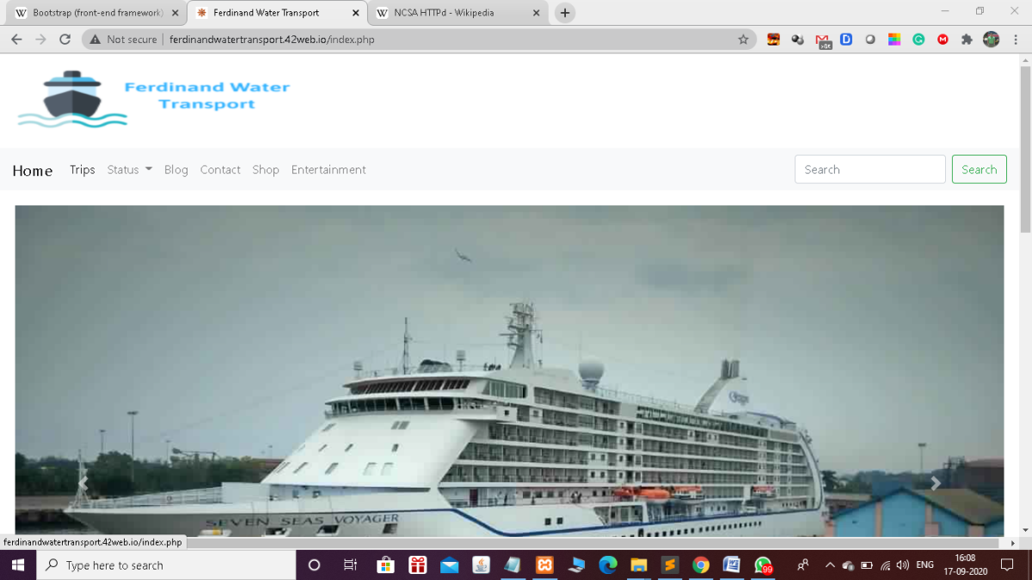

*Index page*

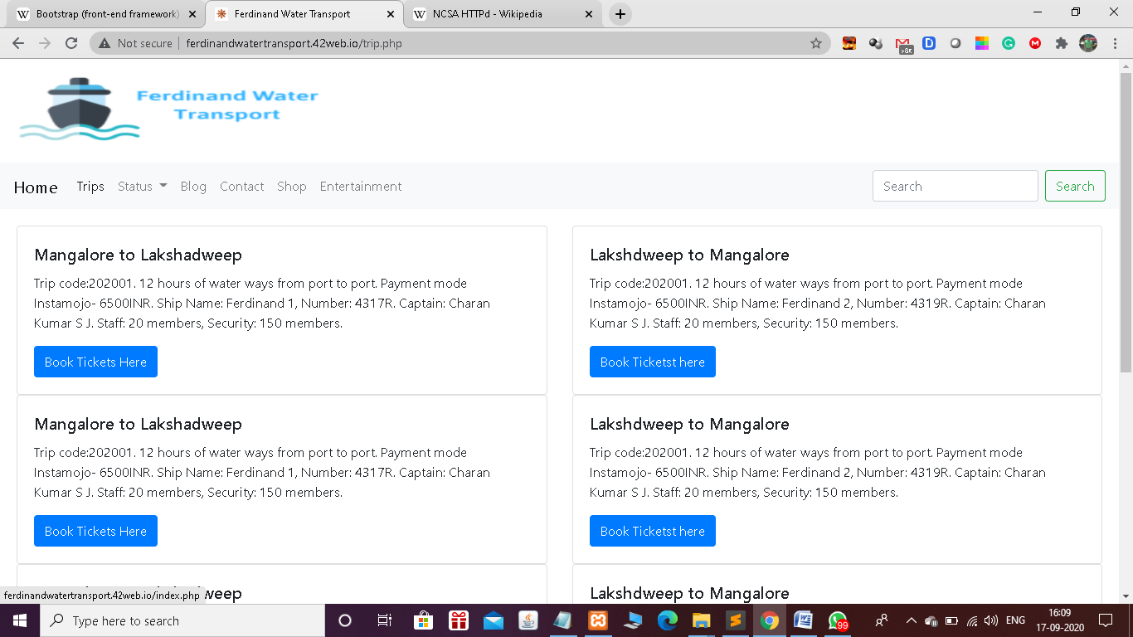

*Trip list page*

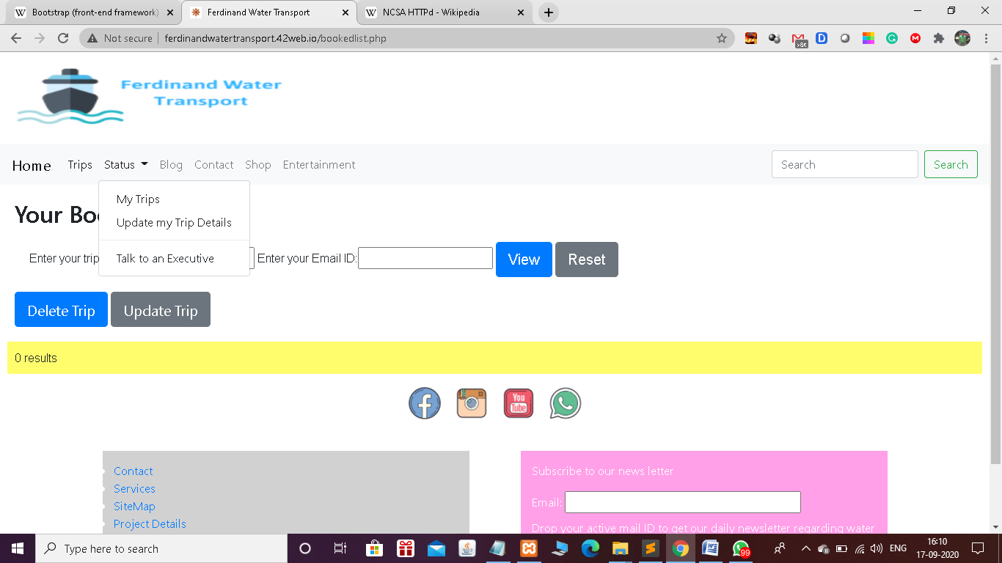

*Trip status page- View, Cancel (delete), Update ( Modify)*

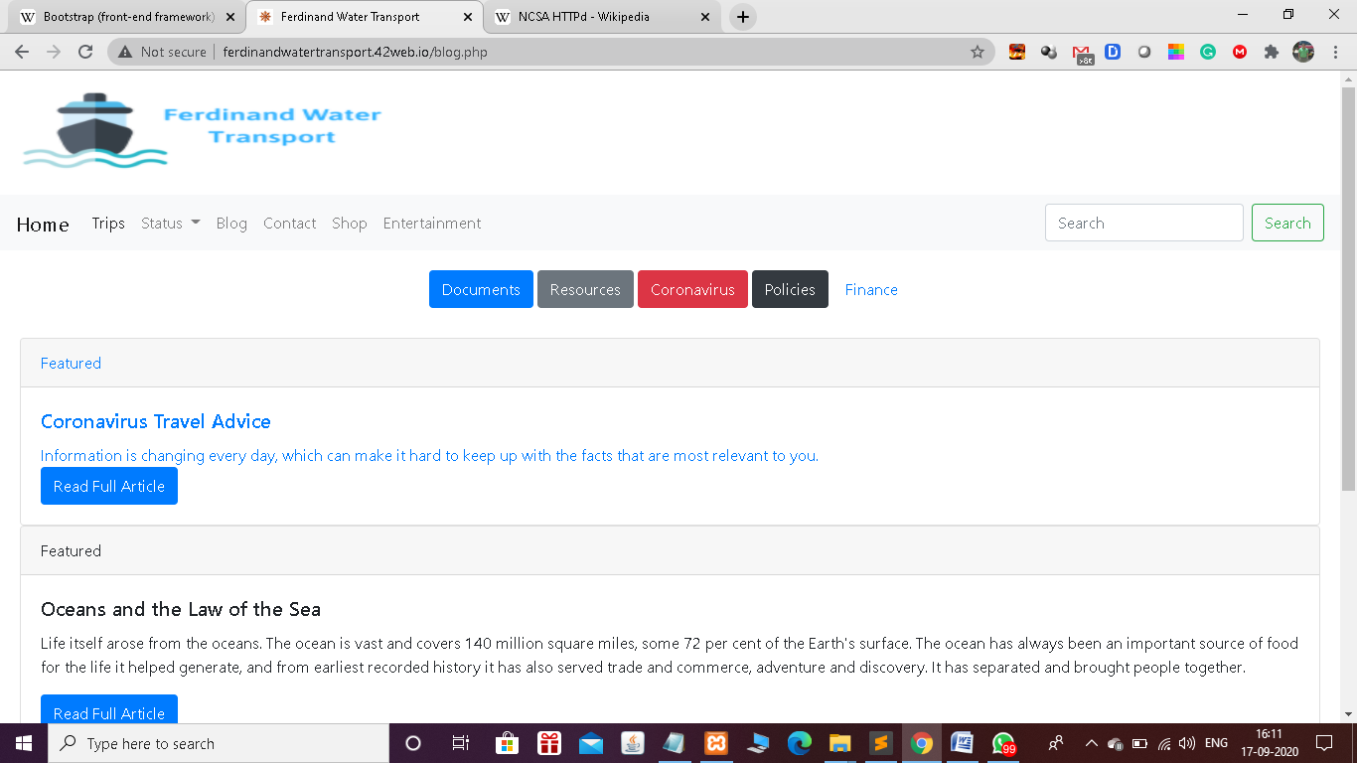

*Blog Page*

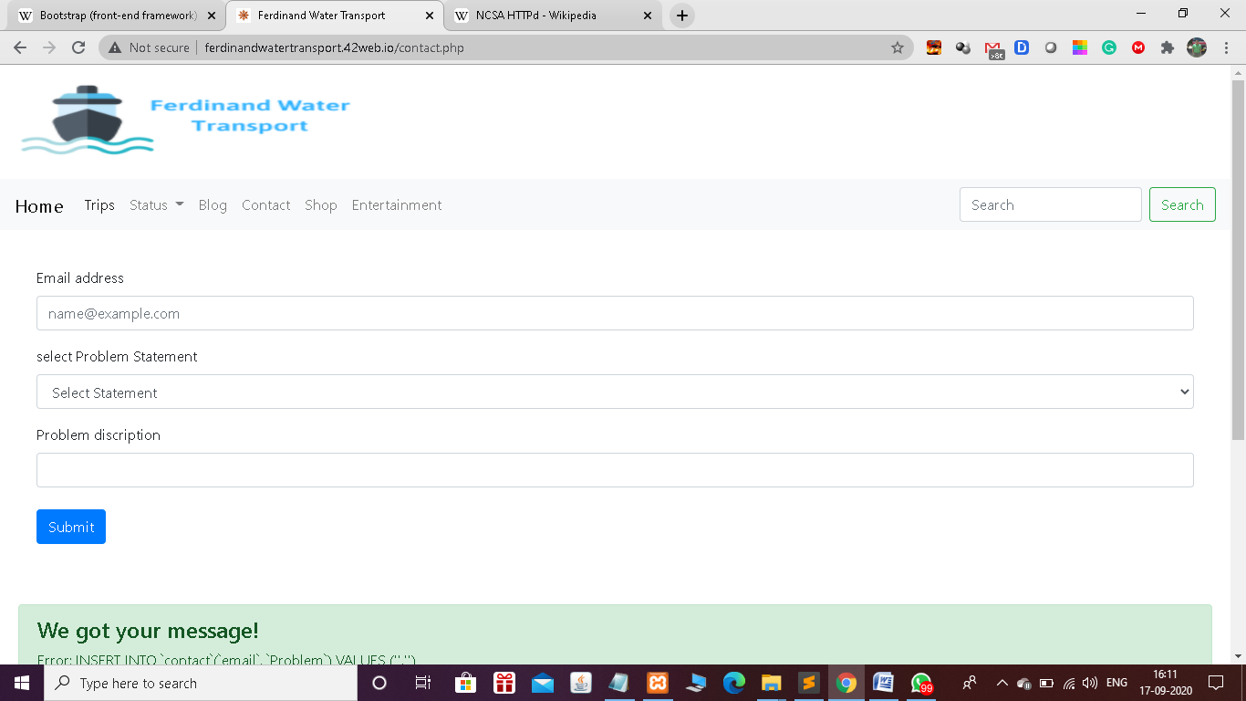

*Contact Page*

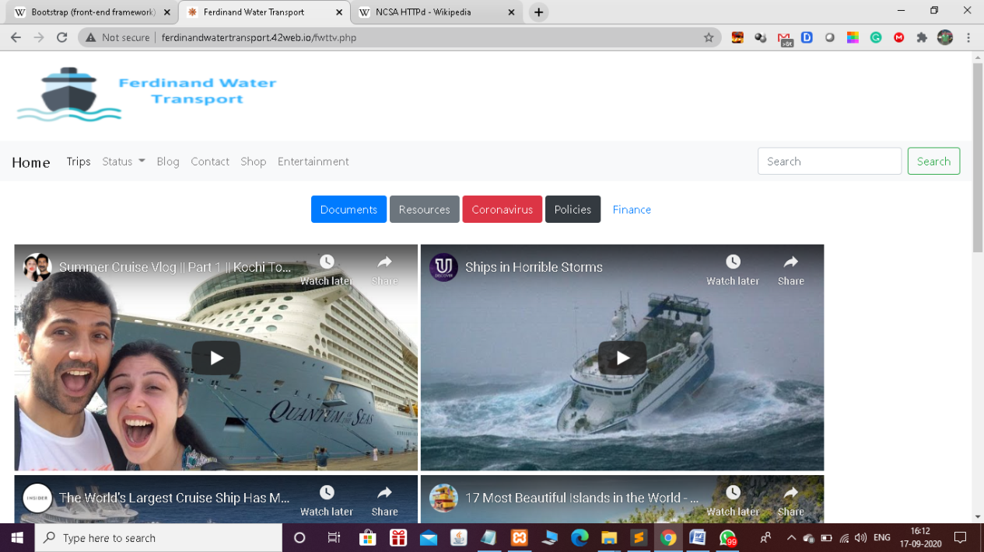

*Entertainment Page*

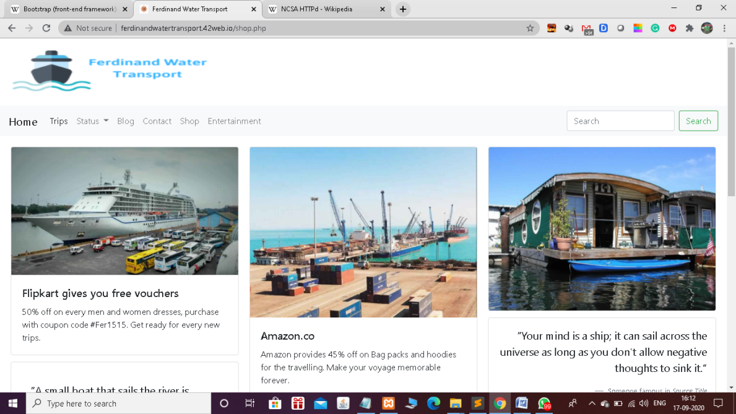

*Shop Page*

***Mobile View of Website***

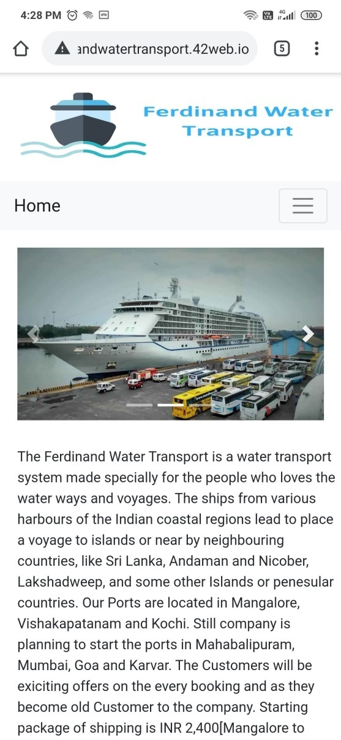 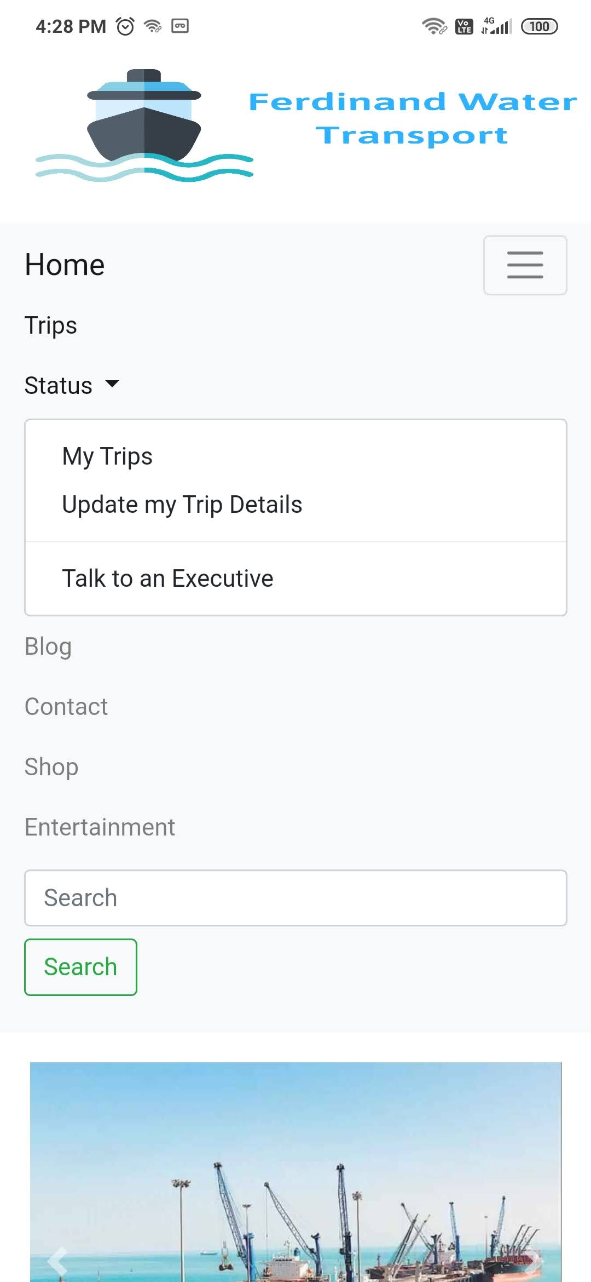

*Home Page Menu Bar*

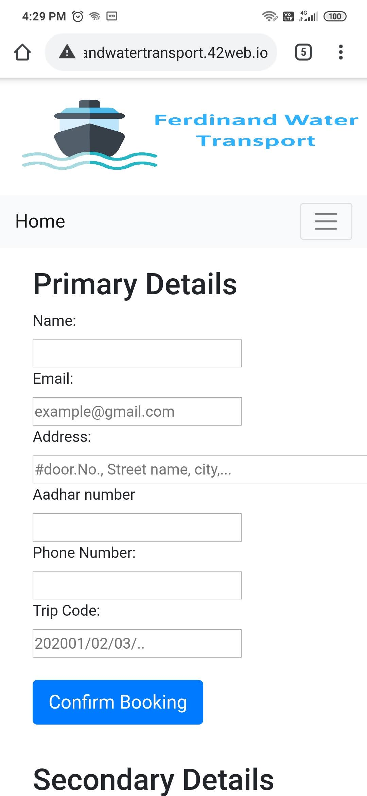 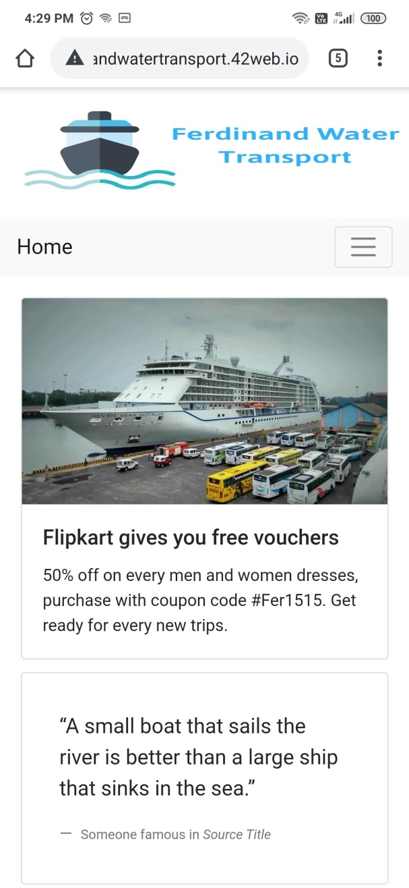

*Booking Page Shopping Page*

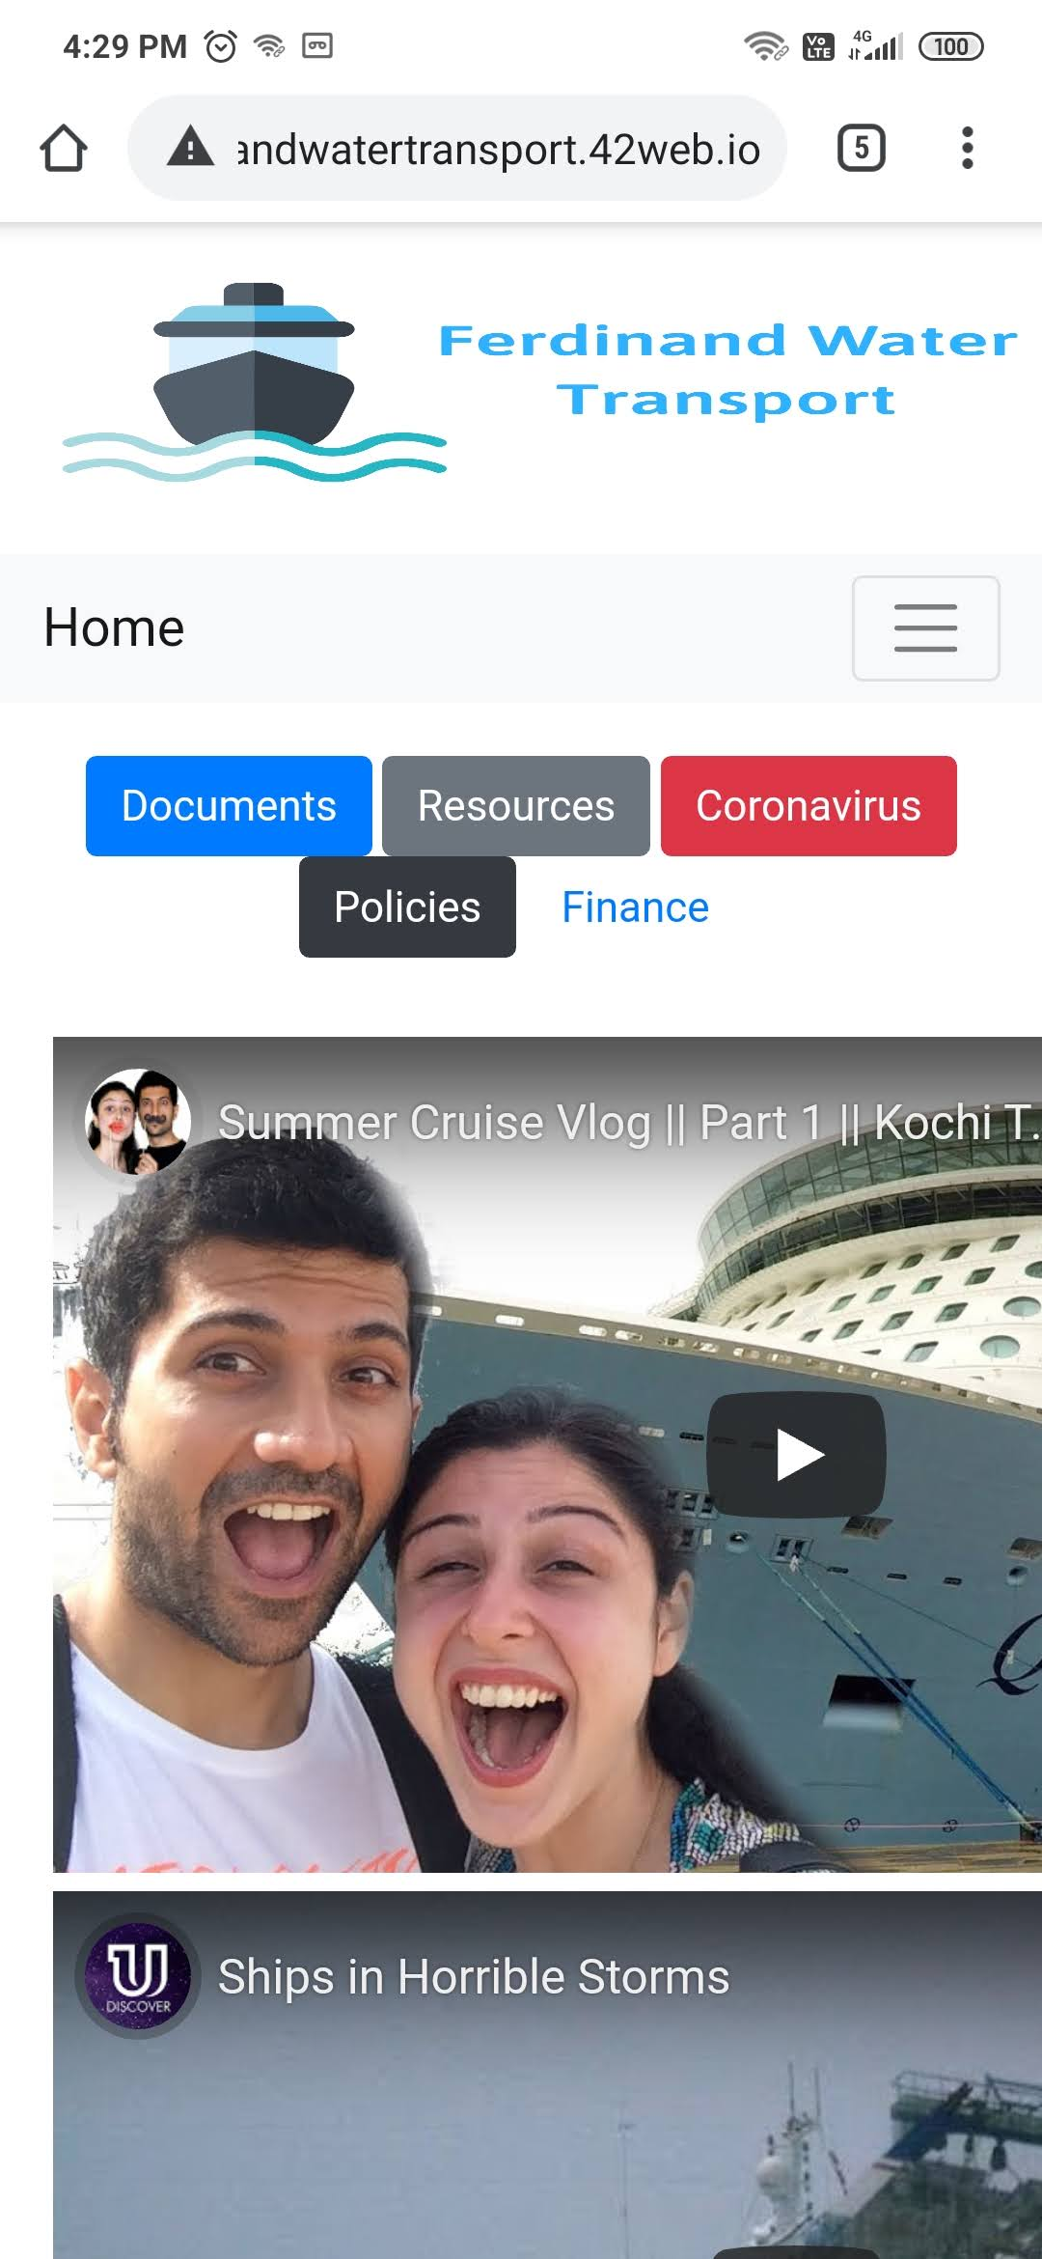 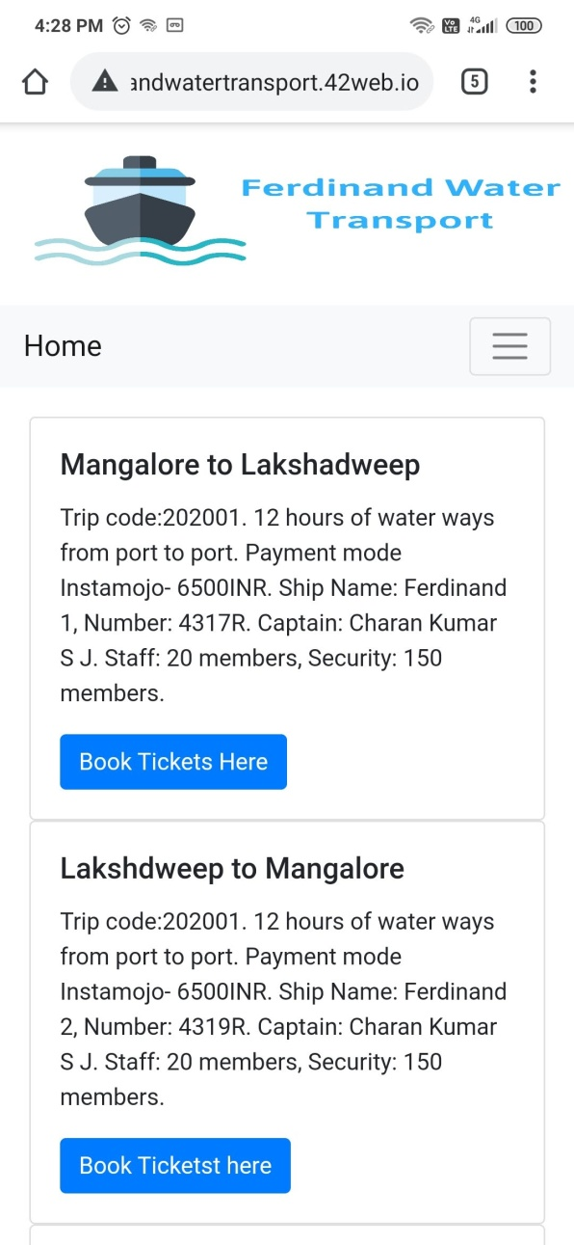

*Entertainment Page List of Trips Page*

**Chapter 8**

**CONCLUSION**

Ferdinand Water Transport is website, which provides facility to book & board the ship to small distance water surrounded lands. Some people who prefer the water voyages they can get to know about the information about the ships which check out from several coastal regional harbors to islands and cities. Our website will help those customers to book the seats in our company passenger ships to go voyage. Customer can register and book the trip in our company to visit various places in their own choose ships at their comfortable budget and schedule of voyage.

In our website, customer can reply back their feedback and let us know about our improvements and new implementations to be done. It has a separate dashboard for customers and admin for insertion, deletion of old record, editing of old record, and display of your records.

**Chapter 9**

**BIBILIOGRAPHY**

* 1. CSS and HTML Web Design – Craigg Rannell
  2. Introduction to Web interaction design – Michael Macaulay
  3. Learning web design – Jennifer Niederst Robbins
  4. [www.w3schools.com](http://www.w3schools.com)
  5. [www.codecademy.com](http://www.codecademy.com)
  6. [www.quackit.com](http://www.quackit.com)
  7. [www.landofcode.com](http://www.landofcode.com)
  8. [www.awwwards.com](http://www.awwwards.com)
  9. [www.intechnic.com](http://www.intechnic.com)
  10. [www.free-css.com](http://www.free-css.com)
  11. Web Programming - Srikanth S